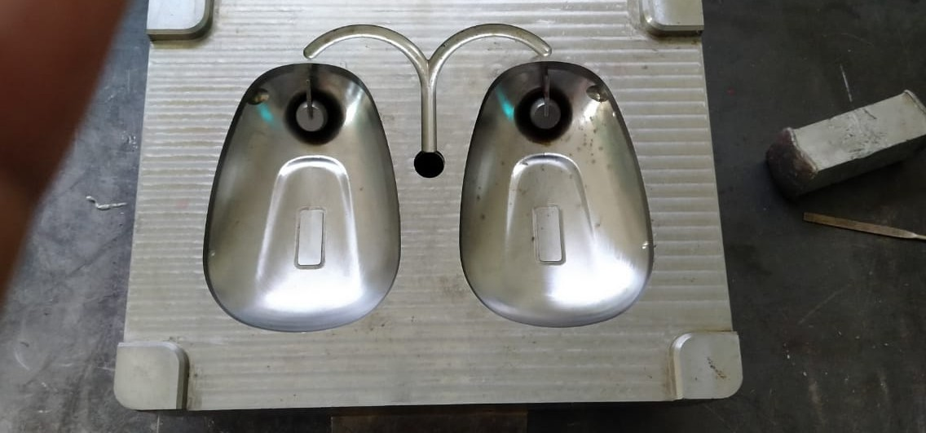
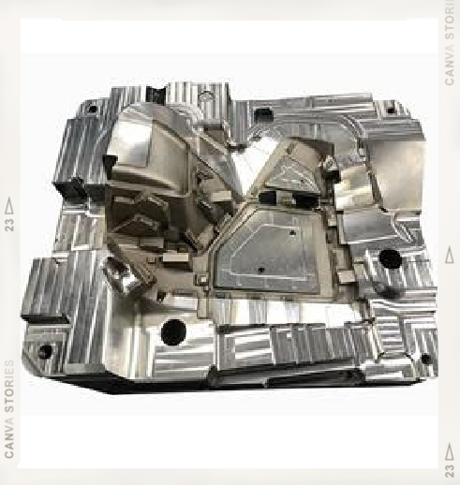
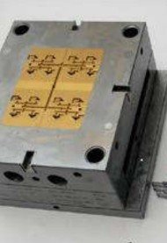
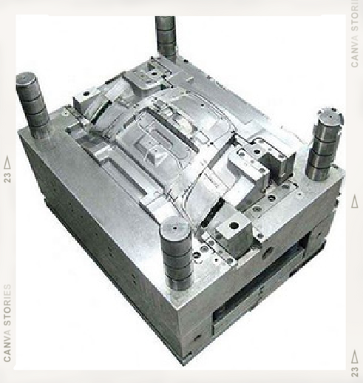
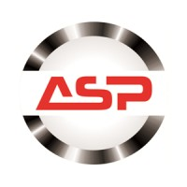

ASP Industries

Contact Us
Our Work Office:

Contact Person:

Email Address:
C-3/2 Phase-2, Mayapuri Industrial Area, New Delhi – 110064.

Prashant: 8512022050 (CEO)

aspindustries336@gmail.com

GSTIN:
07JZXPS9316G1ZB

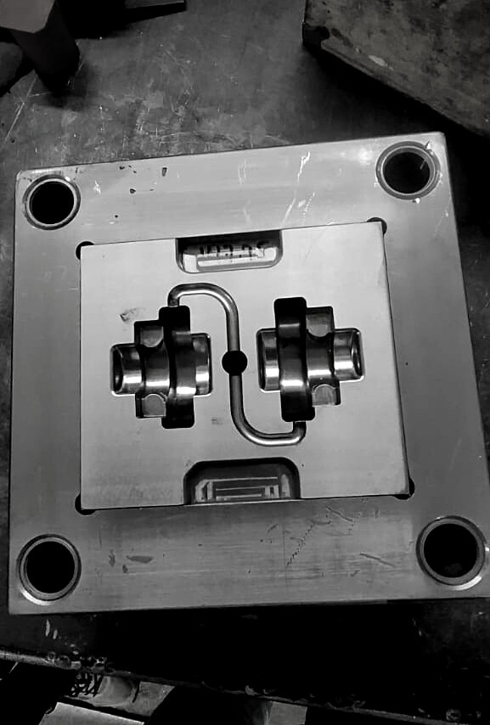
About Us
Our Company aims to become the best die and mold manufacturer in India over the next decade.

Established in 2006,ASP Die & Components manufactures all forms of best quality Injection mold & Machining components.
We commit to deliver high quality products consistently through careful planning and skilled labor. We make use of best-in-class machines for best quality work.

ASP Promises
01

02
03
04

Vision
We want to become a very valuable addition to our partners and customers

Mission
We want to control the primary technology behind the manufacturing of products.

Quality
Quality of products is our biggest priority which leads us to customer satisfaction.

Safety
We have all the necessary equipment like Safety shoes, Gloves etc.

Certificat es, We are a Government Registered company under MSME.
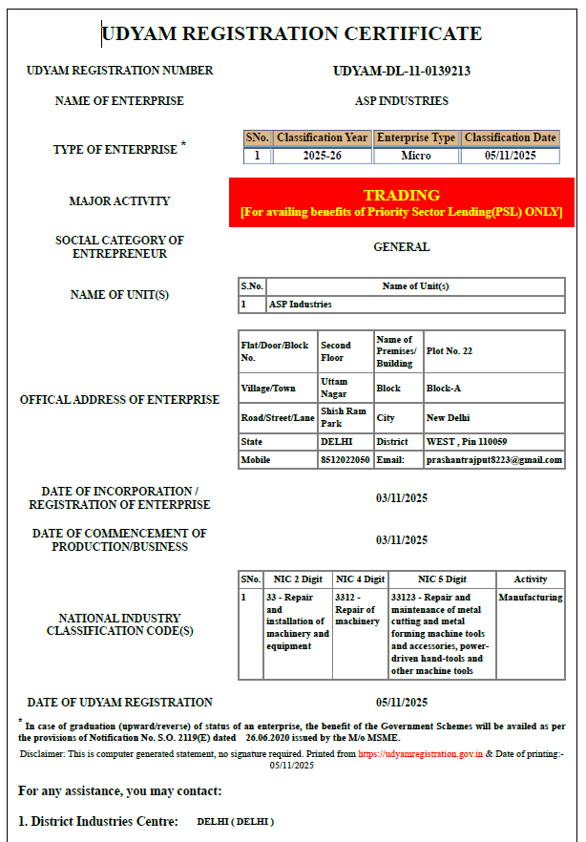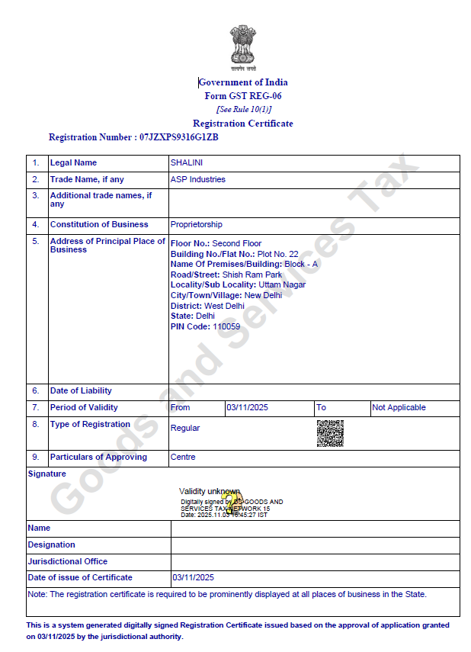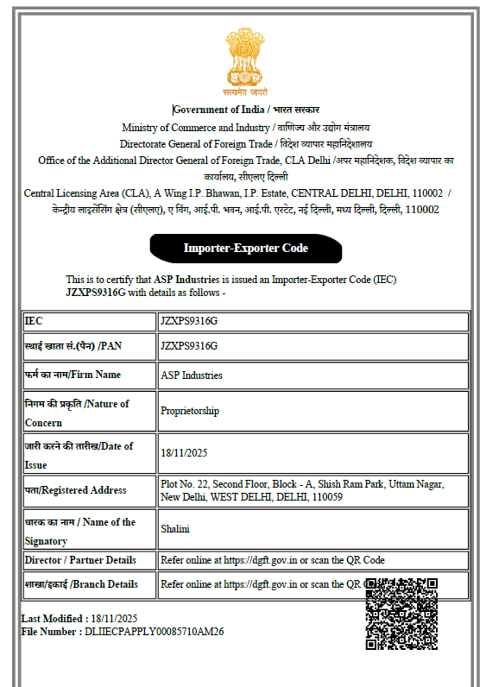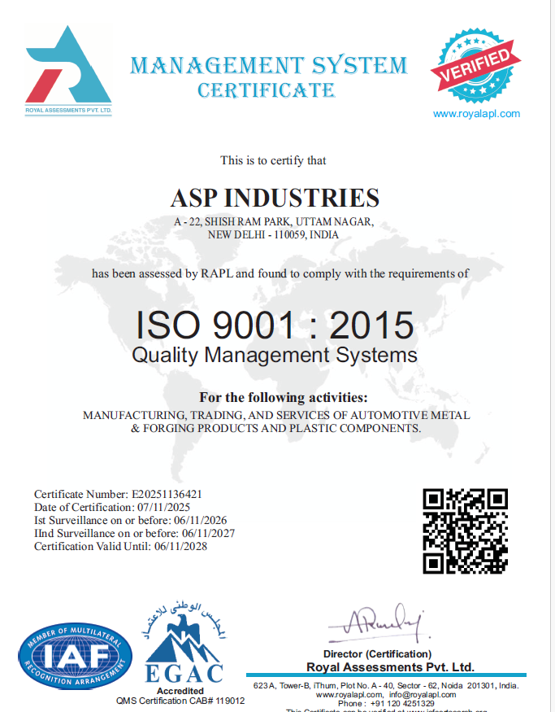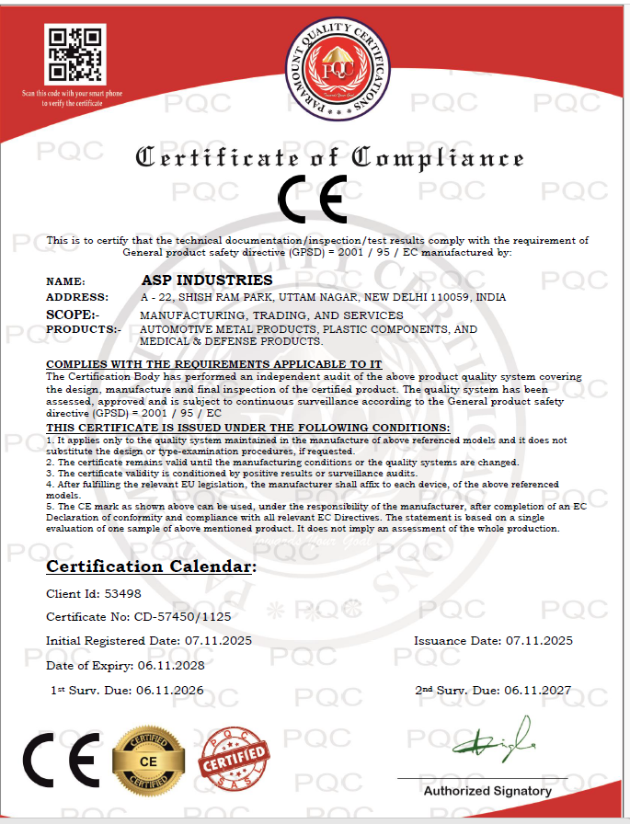

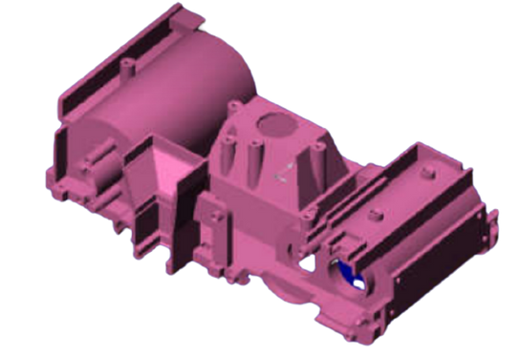
Computer Integrated Manufacturing

CAD

Our CAD facility includes Siemens Nx-10, Cimatron E and AutoCAD

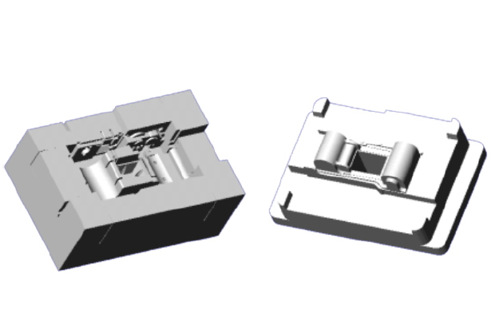
Core & Cavity extraction using these software’s considerably reduces Tool Design Lead Time and Improves Mold Quality.

Core / Cavity Extraction

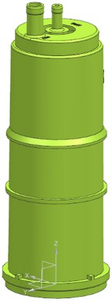
Part: Chassis

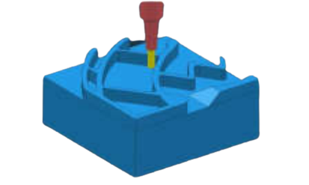
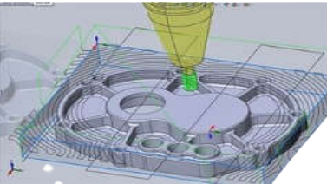
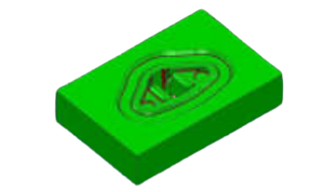
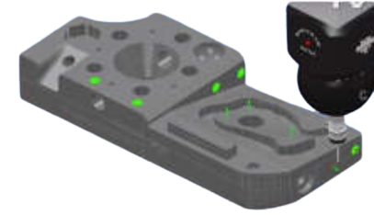
CAM

Computer Aided Manufacturing (CAM) is the use of software and computer-controlled machinery to automate a manufacturing process.

Our CAM Facility includes Cimatron E and SolidWorks.

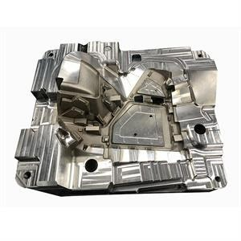
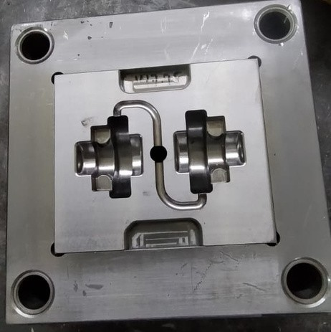
Molds
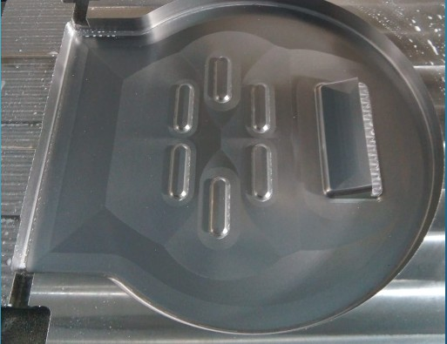
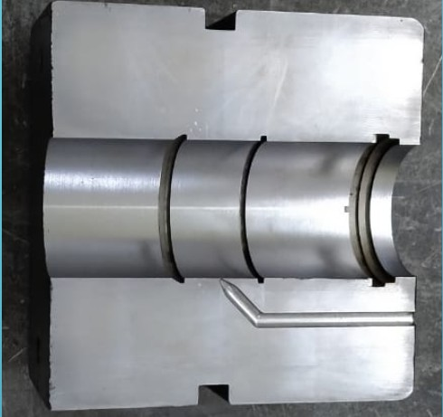

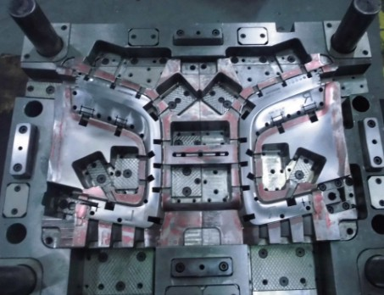
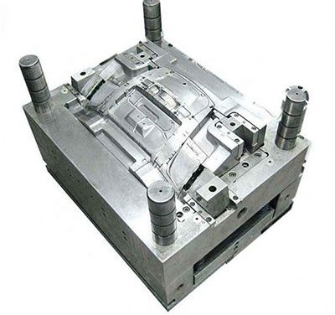

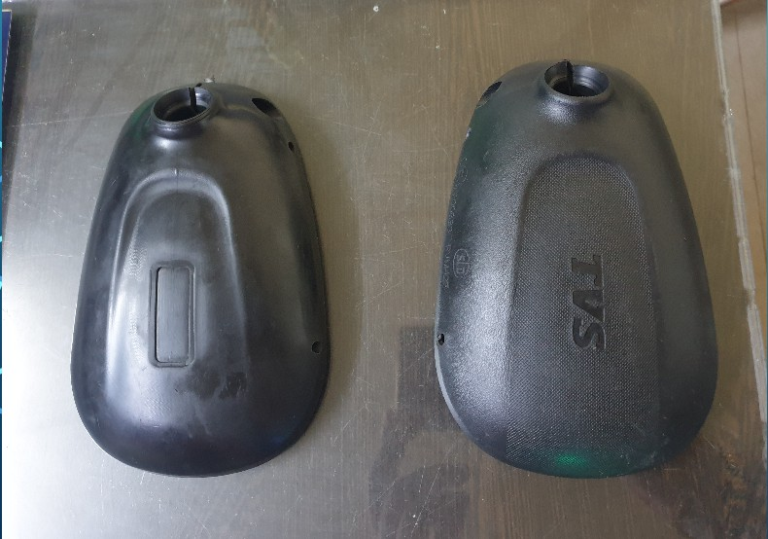
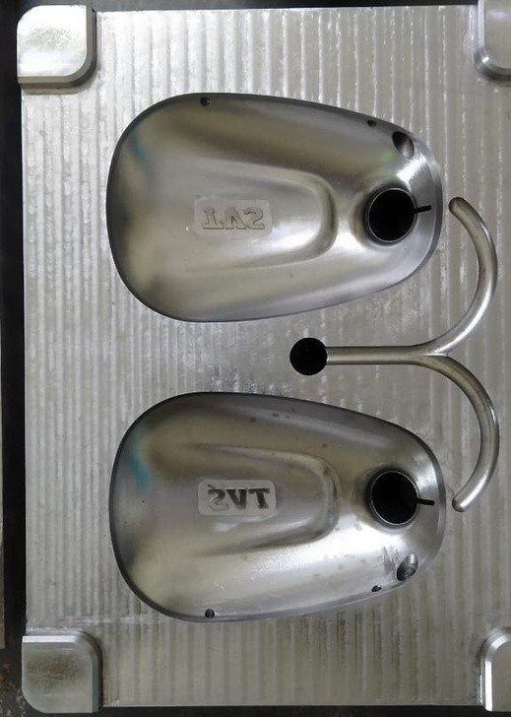
Components from our Molds & Machining Parts.

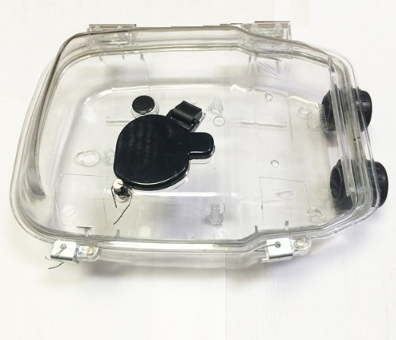
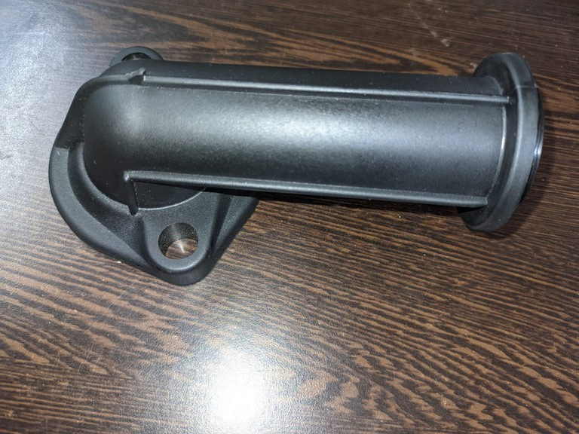
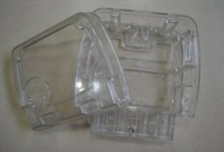
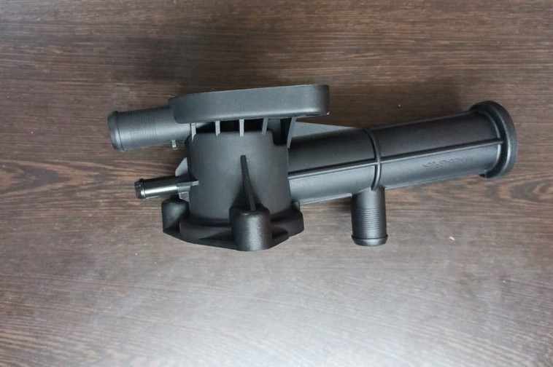
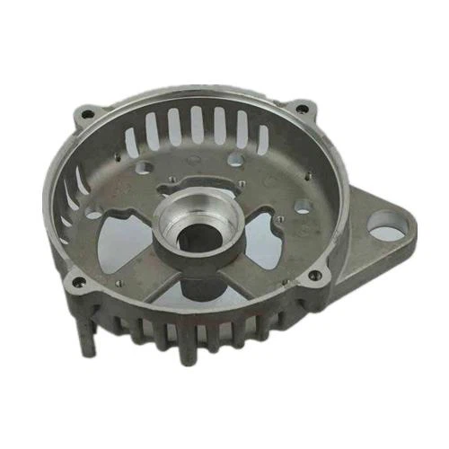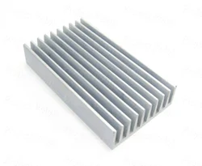

Machine Facilities
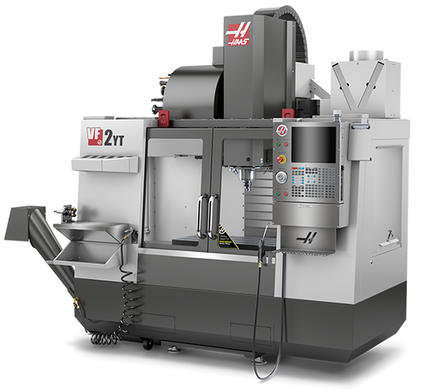
Vertical Machining Centre

Model |  | VF2-YT HAAS
Max job size | MM | 1000 * 510
Max job weight Kg | Kg | 650
Max travel (X/Y/Z) | MM | 760 * 510 * 510
Min cutter dia | MM | 0.8
Max cutter dia | MM | 150
Rapid feed  Min RPM | mm/min | 30000  100
Max RPM |  | 8100
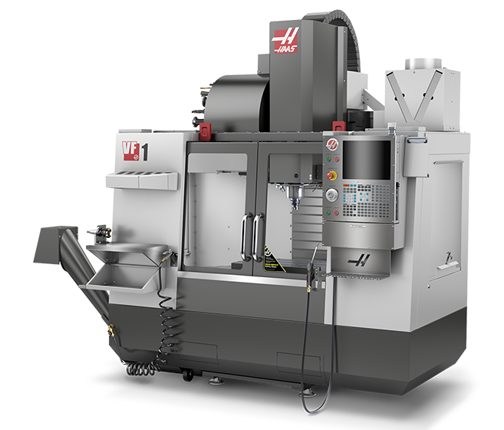
Vertical Machining Center

Model |  | VF1 HAAS
Max Travel  Min cutter dia. | MM | 508 * 408 * 508  0.8
Min RPM |  | 80
Max RPM |  | 7500
Repeatability | MM | 0.010
Accuracy | MM | 0.006

Machine Facilities
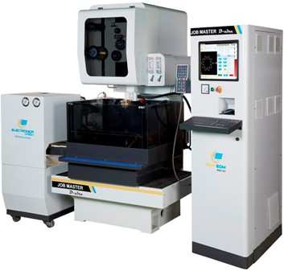
WIRECUT MACHINE
MM

Model

Travel (X/Y/Z)

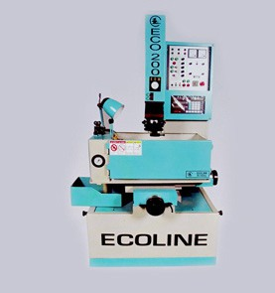
ZNC EDM Machine

ELECTRONICA HI-TECH
450*350*250

Model |  | Ecoline
Travel (X/Y/Z) | MM | 300 * 200 * 200
Max job weight Kg | Kg | 300
Machine Weight | Kg | 1200

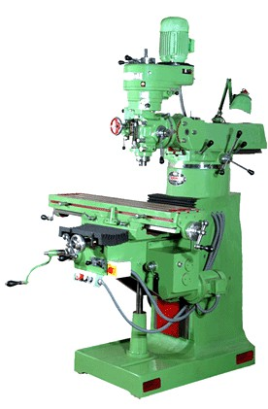
Machine Facilities
365
240
40
MM MM
MM
Max job Length Max Dia
Bore Dia
Galaxy Midas 6

Cylindrical Grinder |  | Hostivar BU-28
Centre Height | MM | 150
Max Job Dia | Kg | 290
Max Job Length | MM | 630

Universal Milling M/C |  | Bhavya
Max job weight | Kg | 250
Max Travel (X/Y/Z) | MM | 500 * 175 * 130
Turning

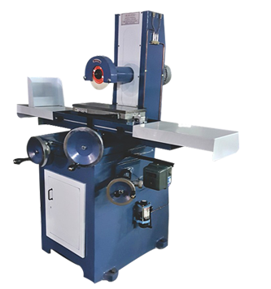
Machine Facilities
6
250
Feet MM
Max job Length Max Dia
Pimco

Surface Grinder |  | Ramana
Max job size | MM | 50 * 25 * 300
Max job weight | Kg | 150
Max Travel (X/Y/Z) | MM | 500 * 250 * 300

Universal Milling M/C |  | Baljeet
Max job weight | Kg | 150
Max Travel (X/Y/Z) | MM | 800 * 250 * 300
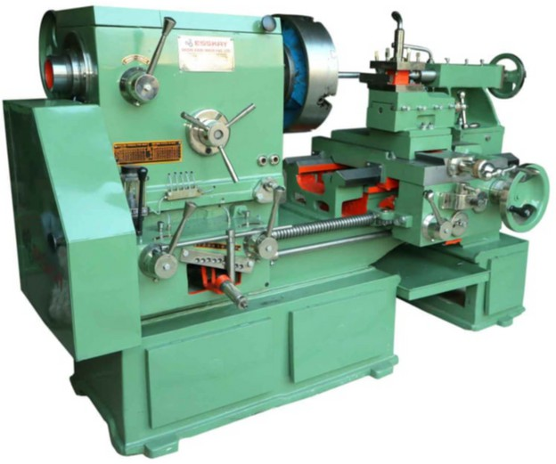
Lathe

Machine Facilities
MM

MM

MM

KG

TON

Machine
Injection Moulding
MODEL

TIE BAR DISTANCE

MINIMUN MOULD HEIGHT

MAX MOULD HEIGHT

MOULD WEIGHT MAX

MACHINE TONNAGE
ELECTRONICA

410

200

450

300

110

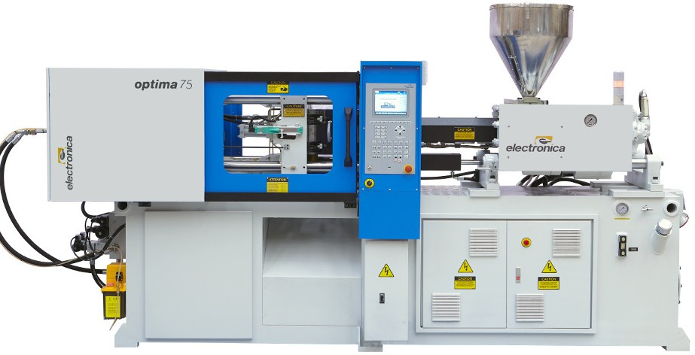

Machine Facilities
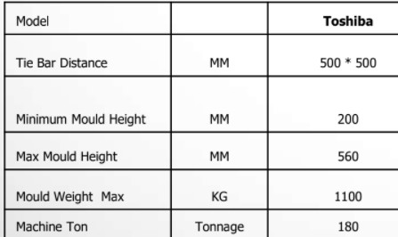
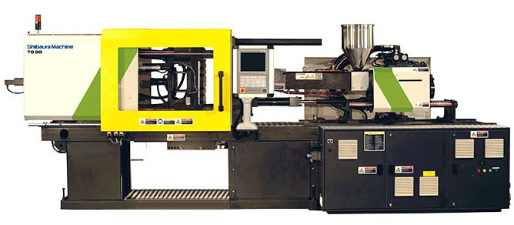
Injection Moulding Machine

Our Esteemed Partners
- PACKMAN
- STEERWELS
- LOFTO DESIGN
4. KK INDUSTRIES (BHIWADI)
- BALAJI AUTO PARTS PVT. LTD.
- Motherson Group
- KRISHNA INDUSTRIES
- MACRO MOULDS
- Sandhar Automotive
- Bharat Lighting
... and many more to come.

Next Steps and
Future Plan

5 AXES VMC-MAZAK
01
Molding 250 Ton- Toshiba Radial Drilling Machines CNC EDM Machines-Phillips CNC Turning or Turn Mill-LMW
02
03
04
05
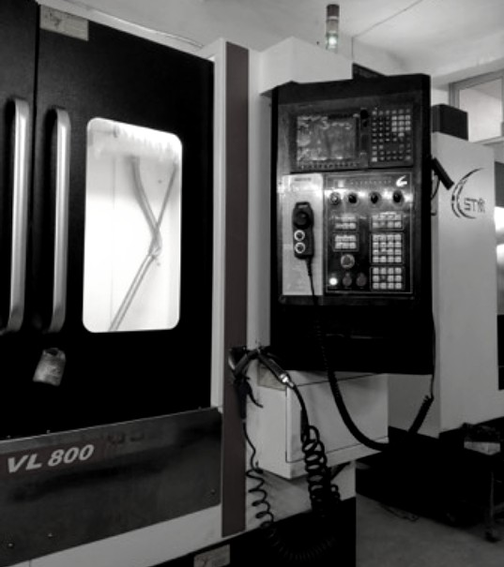
Thank you!
We look forward to long term business from your esteemed organization.

